Project Planning Phase
Project Planning Template (Product Backlog, Sprint Planning, Stories, Story points)

Date | 01 July 2026
Team ID
Project Name | DarshanEase – Temple Darshan Booking System
Maximum Marks | 5 Marks

Product Backlog, Sprint Schedule, and Estimation (4 Marks)
Use the below template to create product backlog and sprint schedule
Sprint | Functional Requirement (Epic) | User Story Number | User Story / Task | Story Points | Priority | Team Member
Sprint-1 | User Authentication | USN-1 | As a user, I can register for the application. | 2 | High | sunil
 |  | USN-2 | As a user, I can log into the application using email and password. | 2 | High | sunil
 |  | USN-3 | As a user, I can securely logout from the application. | 1 | Medium | sunil
Sprint-2 | Temple Module | USN-4 | As a user, I can view all temples. | 2 | High | sunil
 |  | USN-5 | As a user, I can search all temples. | 2 | High | sunil
 |  | USN-6 | As a user, I can view temple details. | 2 | High | sunil
Sprint-3 | Booking Module | USN-7 | As a User , I can View Available darshan Slots | 2 | High | Sunil
 |  | USN-8 | As a user, I can book a darshan slot. | 3 | High | Sunil
 |  | USN-9 | As a user, I can view my bookings. | 2 | High | Sunil
 |  | USN-10 | As a user, I can cancel my booking. | 2 | Medium | Sunil
Sprint-4 | Admin Module | USN-11 | As an admin, I can manage temples. | 3 | High | Sunil
 |  | USN-12 | As an admin, I can manage darshan slots. | 3 | High | Sunil
 |  | USN-13 | As an admin, I can view all bookings. | 2 | High | Sunil
 |  | USN-14 | As an admin, I can access the dashboard. | 2 | Medium | Sunil

Project Tracker, Velocity & Burndown Chart: (4 Marks)
Sprint | Total Story Points | Duration | Sprint Start Date | Sprint End Date (Planned) | Story Points Completed (as on Planned End Date) | Sprint Release Date (Actual)
Sprint-1 | 15 | 5 Days | 24 Oct 2022 | 01 July 2026 | 15 | 05 July 2026
Sprint-2 | 15 | 5 Days | 06 July 2026 | 10 July 2026 | 15 | 10 July 2026
Sprint-3 | 15 | 5 Days | 11 July 2026 | 15 July 2026 | 15 | 15 July 2026
Sprint-4 | 15 | 5 Days | 16 July 2026 | 20 July 2026 | 15 | 20 July 2026

Velocity:
Velocity Calculation
Total Story Points Completed = 60
Number of Sprints = 4
Average Team Velocity = 60 / 4 = 15 Story Points per Sprint
Average Velocity per Day = 15 / 5 = 3 Story Points per Day
Observation:
The team maintained a consistent velocity of 15 story points per sprint, indicating steady progress throughout the project.
Burndown Chart/ Table:

Day | Remaining
Day 1 | 60
Day 2 | 52
Day 3 | 44
Day 4 | 35
Day 5 | 28
Day 6 | 20
Day 7 | 15
Day 8 | 10
Day 9 | 5
Day 10 | 0
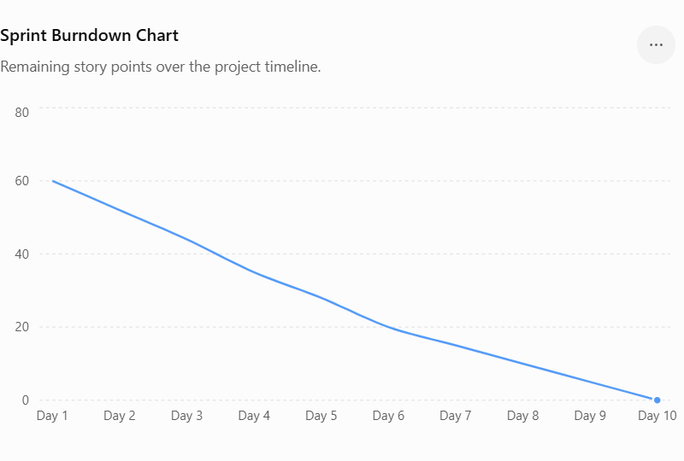

Reference:
https://www.atlassian.com/agile/project-management
https://www.atlassian.com/agile/tutorials/how-to-do-scrum-with-jira-software
https://www.atlassian.com/agile/tutorials/epics
https://www.atlassian.com/agile/tutorials/sprints
https://www.atlassian.com/agile/project-management/estimation
https://www.atlassian.com/agile/tutorials/burndown-charts

